Question 1.

Which of the following can make a parallel beam of light when light from a point source is incident on it?

(a) Concave mirror as well as convex lens

(b) Convex mirror as well as concave lens

(c) Two plane mirrors placed at 90° to each other

(d) Concave mirror as well as concave lens

Answer: (a) Concave mirror as well as convex lens

Question 2.

A 10 mm long awl pin is placed vertically in front of a concave mirror. A 5 mm long image of the awl pin is formed at 30 cm in front of the mirror. The focal length of this mirror is

(a) -30 cm

(b) -20 cm

(c) -40cm

(d) -60 cm

Answer: (b) -20 cm

Question 3.

Under which of the following conditions a concave mirror can form an image larger than the actual object?

(a) When the object is kept at a distance equal to its radius of curvature

(b) When object is kept at a distance less than its focal length

(c) When object is placed between the focus and centre of curvature

(d) When object is kept at a distance greater than its radius of curvature

Answer: (c) When object is placed between the focus and centre of curvature

Question 4.

The diagrams showing the correct path of the ray after passing through the

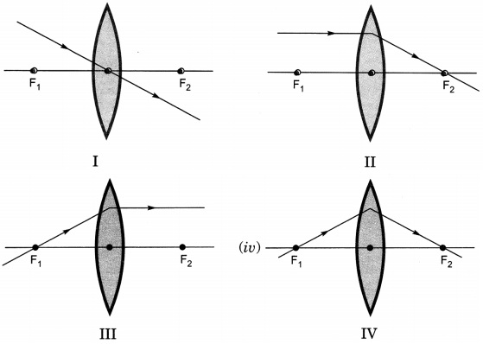

(a) II and III only

(b) I and II only

(c) I, II and III

(d) I, II and IV

Answer: (c) I, II and III

Question 5.

A light ray enters from medium A to medium B as shown in figure. The refractive index of medium B relative to A will be

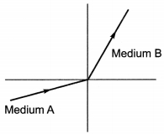

(a) greater than unity

(b) less than unity

(c) equal to unity

(d) zero

Answer: (a) greater than unity

Question 6.

Beams of light are incident through the holes A and B and emerge out of box through the holes C and D respectively as shown in the figure. Which of the following could be inside the box?

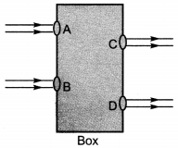

(a) A rectangular glass slab

(b) A convex lens

(c) A concave lens

(d) A prism

Answer: (a) A rectangular glass slab

Question 7.

A beam of light is incident through the holes on side A and emerges out of the holes on the other face of the box as show in the figure. Which of the following could be inside the box?

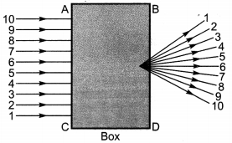

(a) Concave lens

(b) Rectangular glass slab

(c) Prism

(d) Convex lens

Answer: (d) Convex lens

Question 8.

Which of the following statements is true?

(a) A convex lens has 4 dioptre power having a focal length 0.25 m

(b) A convex lens has -4 dioptre power having a focal length 0.25 m

(c) A concave lens has 4 dioptre power having a focal length 0.25 m

(d) A concave lens has -4 dioptre power having a focal length 0.25 m.

Answer: (a) A convex lens has 4 dioptre power having a focal length 0.25 m

Question 9.

Magnification produced by a rear view mirror fitted in vehicles

(a) is less than one

(b) is more than one

(c) is equal to one

(d) can be more than or less than one depending upon the position of the object in front of it.

Answer: (a) is less than one

Question 10.

Rays from Sun converge at a point 15 cm in front of a concave mirror. Where should an object be placed so that size of its image is equal to the size of the object?

(a) 15 cm in front of the mirror

(b) 30 cm in front of the mirror

(c) between 15 cm and and 30 cm in front of the mirror

(d) more than 30 cm in front of the mirror

Answer: (b) 30 cm in front of the mirror

Question 11.

A full length image of a distant tall building can definitely be seen by using

(a) a concave mirror

(b) a convex mirror

(c) a plane mirror

(d) both concave as well as plane mirror

Answer: (b) a convex mirror

Question 12.

In torches, search lights and headlights of vehicles the bulb is placed

(a) between the pole and the focus of the reflector

(b) very near to the focus of the reflector

(c) between the focus and centre of curvature of the reflector

(d) at the centre of curvature of the reflector

Answer: (b) very near to the focus of the reflector

Question 13.

The laws of reflection hold good for

(a) plane mirror only

(b) concave mirror only

(c) convex mirror only

(d) all mirrors irrespective of their shape

Answer: (d) all mirrors irrespective of their shape

Question 14.

The path of a ray of light coming from air passing through a rectangular glass slab traced by four students are shown as A, B, C and D in figure. Which one of them is correct?

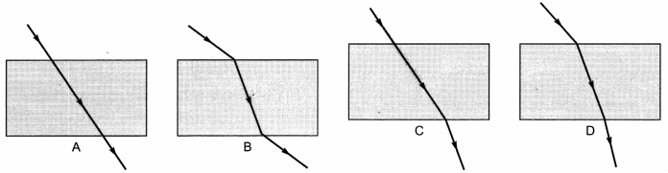

(a) A

(b) B

(c) C

(d) D

Answer: (b) B

Question 15.

You are given water, mustard oil, glycerine and kerosene. In which of these media a ray of light incident obliquely at same angle would bend the most?

(a) Kerosene

(b) Water

(c) Mustard oil

(d) Glycerine

Answer: (d) Glycerine

Question 16.

Which of the following ray diagrams is correct for the ray of light incident on a concave mirror as shown in figure?

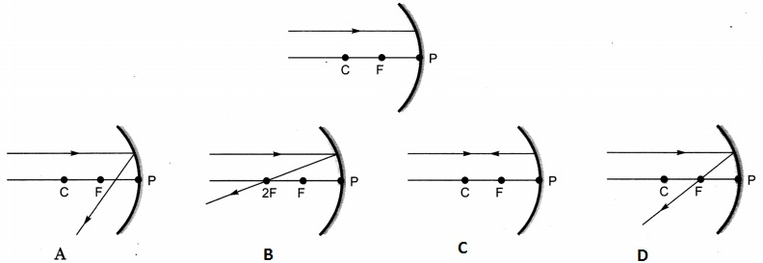

(a) Fig. A

(b) Fig. B

(c) Fig. C

(d) Fig. D

Answer: (d) Fig. D

Question 17.

Which of the following ray diagrams is correct for the ray of light incident on a lens shown in figure?

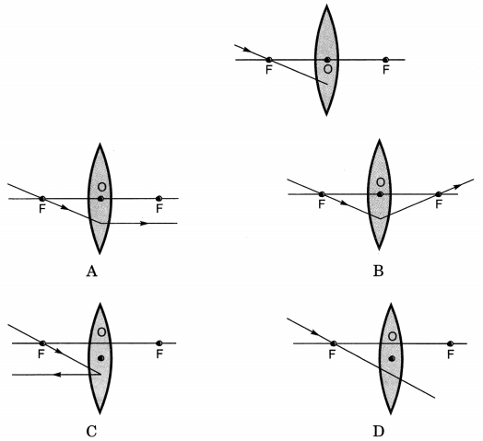

(a) Fig. A

(b) Fig. B

(c) Fig. C

(d) Fig. D

Answer: (a) Fig. A

Question 18.

A child is standing in front of a magic mirror. She finds the image of her head bigger, the middle portion of her body of the same size and that of the legs smaller. The following is the order of combinations for the magic mirror from the top.

(a) Plane, convex and concave

(b) Convex, concave and plane

(c) Concave, plane and convex

(d) Convex, plane and concave

Answer: (c) Concave, plane and convex

Question 19.

In which of the following, the image of an object placed at infinity will be highly diminished and point sized?

(a) Concave mirror only

(b) Convex mirror only

(c) Convex lens only

(d) Concave mirror, convex mirror, concave lens and convex lens

Answer: (d) Concave mirror, convex mirror, concave lens and convex lens

Question 20.

Light travel fastest in

(a) Water

(b) Air

(c) Glass

(d) Diamond

Answer: (b) Air

Question 21.

A student used a device (X) to obtain/focus the image of a well illuminated distant building on a screen (S) as shown alongside in the diagram. Select the correct statement about the device (X).

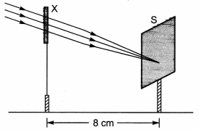

(a) This device is a concave lens of focal length 8 cm.

(b) This device is a convex mirror of focal length 8 cm.

(c) This device is a convex lens of focal length 4 cm.

(d) This device is a convex lens of focal length 8 cm.

Answer: (d) This device is a convex lens of focal length 8 cm.

Question 22.

A student obtains a sharp image of the distant window (W) of the school laboratory on the screen (S) using the given concave mirror (M) to determine its focal length. Which of the following distances should he measure to get the focal length of the mirror?

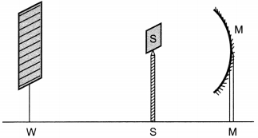

(a) MW

(b) MS

(c) SW

(d) MW- WS

Answer: (b) MS

Question 23.

The mirror having reflection surface curved outward

(a) plane mirror

(b) concave mirror

(c) convex mirror

(d) cylindrical mirror

Answer: (c) convex mirror

Question 24.

The mirror having reflecting surface curved inwards

(a) plane mirror

(b) convex mirror

(c) cylindrical mirror

(d) concave mirror

Answer: (d) concave mirror

Question 25.

The mirror used as rear-view mirror in vehicles

(a) convex mirror

(b) plane mirror

(c) cylindrical mirror

(d) concave mirror

Answer: (a) convex mirror

Question 26.

The deviation of light ray from its path when it travels from one transparent medium to another transparent medium is called

(a) reflection

(b) refraction

(c) dispersion

(d) scattering

Answer: (b) refraction

Question 27.

Convex lens is also known as

(a) converging lens

(b) diverging lens

(c) radial lens

(d) axial lens

Answer: (a) converging lens

Question 28.

The image which is formed behind the mirror

(a) real image

(b) virtual image

(c) blue image

(d) partial image

Answer: (b) virtual image